Meeting held on 11th February at the Surgery at 10.30 am
Present | Martin Connolly (Chair), Tricia Clough, Lilian Cross, Jan Allan, Nigel Bain, Jean Nuckey, Sandy Usher-Smith, Audrey Sparkes. Fiona Brown
Apologies | Christine Bewley, Maureen Cook, Maurice Gemmell, Lyn Warren, Pamela Davis, Jack Adams
Distribution | All

Item | Details discussed | Action  By | By  When
- 1 | Welcome by Chair  - Minutes of the adhoc Meeting held on 10th December 2019 were reviewed
 | Matters arising.  The Presentations on the 10th December had been well received  Flu vaccinations had been promoted on Brookmans Web site  The PPG will support the practice in this year’s “Patient Survey”  The Carers event was a success, but not well supported | Lilian
 | Potterells Update  PCN.  Network surgeries are Wrafton House (Wellfield Road, Hatfield), Lister House (The Common, Hatfield) and Burvill House (Dellfield Road, Hatfield).  We are working well as a Network and have employed both the Clinical Pharmacist and the Social Prescriber (as below)  We meet on a monthly basis and will continue to look at what is best for our patients – 1 idea is next year 2021 to have an extended hours service in Hatfield.  E Consulting  Going Live 3rd March 2020- Soft Launch  Martin Suggested that PPG member be part of the Implementation team  Lilian to update following discussions with the E Consult team  Social Prescribing  Fiona – Works 4 days per week across the 4 surgeries in the Network.  Fiona gave a small talk on her remit within the practices – she is here to “Provide support and help with any patient with a non-medical or mental health requirement”  Blood pressure Machine  Jack and other members of the PPG have commented about this subject over several meetings and via correspondence. Fortunately, Dr Ridout has assisted our cause, when he indicated that once E Consultation was up and running, the surgery Blood Pressure Machine will come into its own. We must now get on with this project, and Jack/Lilian and other interested PPG members can assist in drawing this ongoing matter to a close. Suggested that as Jack is highlighting “Blood Pressure” on the May focus board, that this be the target date to finalise this project  Appointments’ and Japanese GP Sugery  Our PPG “agent” in Japan, has sent information about the appointments and health system in Japan. Interestingly, some other members of the PPG have experience of Japan and Health. There are fundamental differences, not to mention the cultural differences. That said, we can always learn from other peoples and countries experiences. Jack is invited to discuss at our next PPG meeting.  Pharmacist  Kumail – works 4 days per week across the 3 practices in our Network (1 day in each surgery). His role will be face to face medication reviews, audits, discharge letters.  Cancel Out Cancer  Delighted that Tricia has indicated volunteering to become the “Champion” for this project. Lilian handed over the brief, and Martin will get further material to better understand this project.  Newsletter  PPG will be producing a newsletter in March, Jan will pull together, but requires PPG input.  Agreed  - Econsult will feature, Lilian would draft something out  - “Social Prescribing”  - Network, updated plans, locations of our network, and potential hub? Lilian and Mark to provide update  - Shingles Vaccine  - Other topics and input wanted please  - Useful emergency numbers  Focus board  Month PPG Member Suggested Topic  February Nigel Bain  March Audrey Social prescribing  April Martin E Consult  May Jack Blood Pressure  June Chris  July Jean  August Eric  September Tricia  October Pamela  November Maurice  December Lyn  Some Topics for April 7th Meeting  Social Media  Garden  Japanese appointment and Practice learning points  AOB  - Lilian suggested that PPG members download the NHS App onto smart phones. Easy access to NHS  - Martin introduced a possible useful flyer for Emergency Numbers. To be included in the forthcoming Newsletter  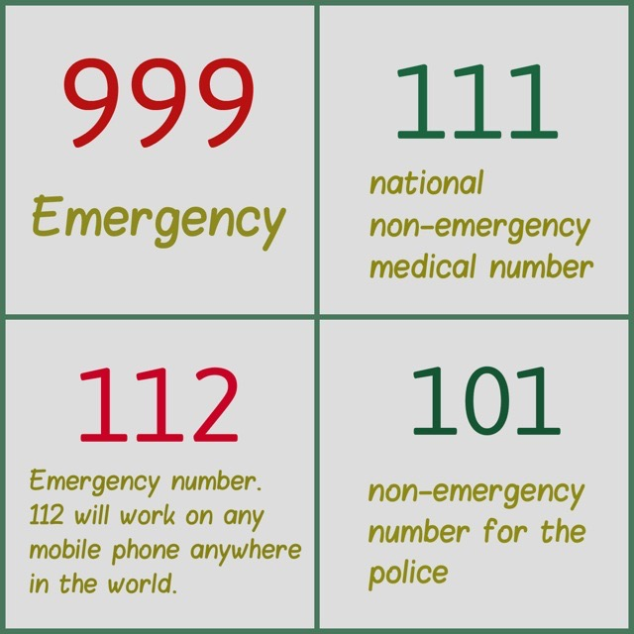  Future PPG meetings.  - April 7th  - June 9th  - August 4th  - October 6th  - December 8th | Lilian/  Martin  Lilian  Lilian/Jack  Lilian/Jack  Lilian/  Tricia/  Martin  All  Lilian/  Martin  Audrey/  Fiona  Lilian  Lilian  All  Jan  All  Martin  Jack  All  Jan/Martin

